Project Problem Statement
A development team needs to establish a basic CI/CD pipeline for a web application. The goal is to automate version control, containerization, building, testing, and deployment processes.

Deliverables
- Git Repository:
  - Create a Git repository: Initialize a new repository for the web application.
  - Branching Strategy:
    - Set up main and develop branches.
    - Create a feature branch for a new feature or bug fix.
  - Add Configuration Files:
    - Create a .gitignore file to exclude files like logs, temporary files, etc.
    - Create a README.md file with a project description, setup instructions, and contribution guidelines.
- Docker Configuration:
  - Dockerfile:
    - Write a Dockerfile to define how to build the Docker image for the web application.
  - Docker Ignore File:
    - Create a .dockerignore file to exclude files and directories from the Docker build context.
  - Image Management:
    - Build a Docker image using the Dockerfile.
    - Push the built Docker image to a container registry (e.g., Docker Hub).
- Jenkins Configuration:
  - Jenkins Job Setup:
    - Create a Jenkins job to pull code from the Git repository.
    - Configure Jenkins to build the Docker image using the Dockerfile.
    - Set up Jenkins to run tests on the Docker image.
    - Configure Jenkins to push the Docker image to the container registry after a successful build.
  - Jenkins Pipeline:
    - Create a Jenkinsfile to define the CI/CD pipeline stages, including build, test, and deploy.
- Ansible Playbook:
  - Basic Playbook Creation:
    - Develop an Ansible playbook to automate the deployment of the Docker container.
  - Playbook Tasks:
    - Install Docker on the target server (if Docker is not already installed).
    - Pull the Docker image from the container registry.
    - Run the Docker container with the required configurations.
  - Inventory File:
    - Create an inventory file specifying the target server(s) for deployment.
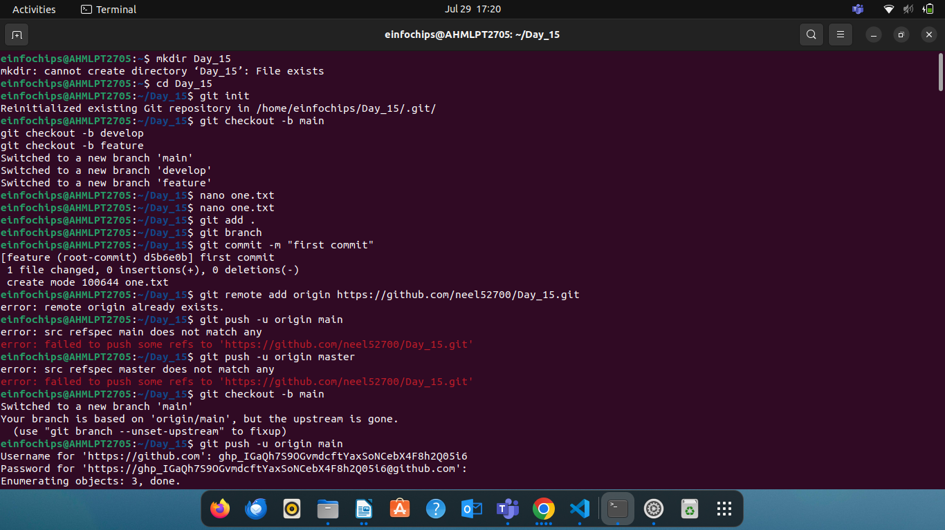

Create Branch

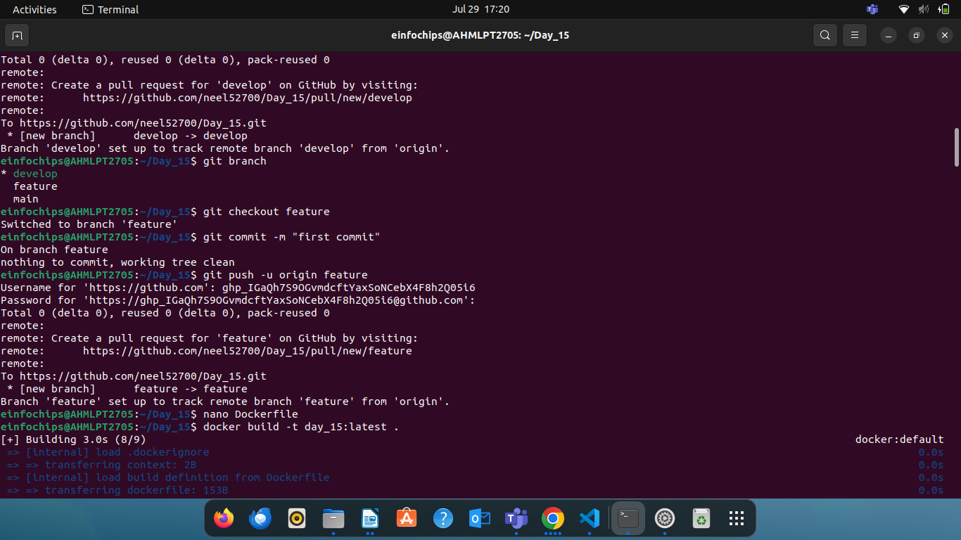

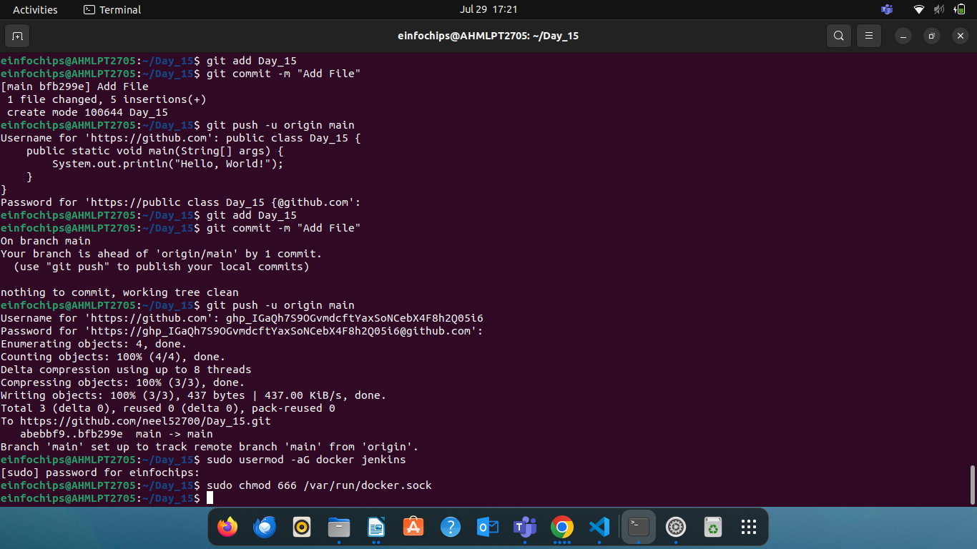

Jenkinsfile
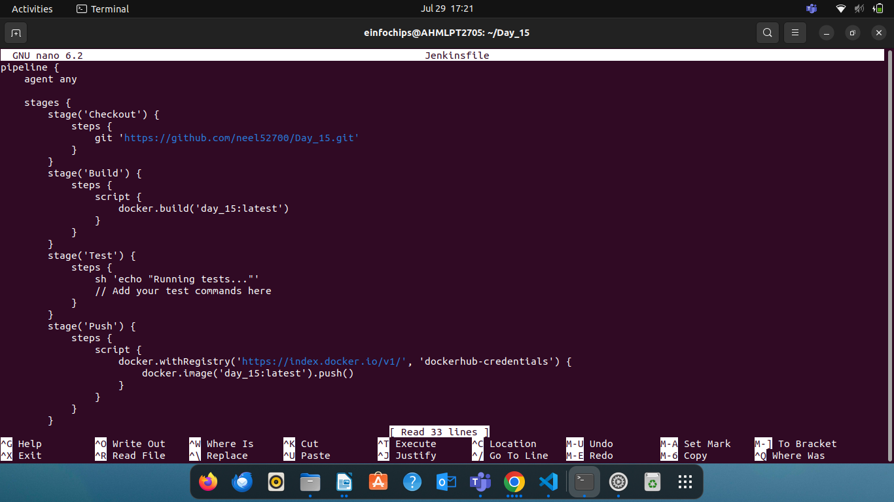

DockerFile

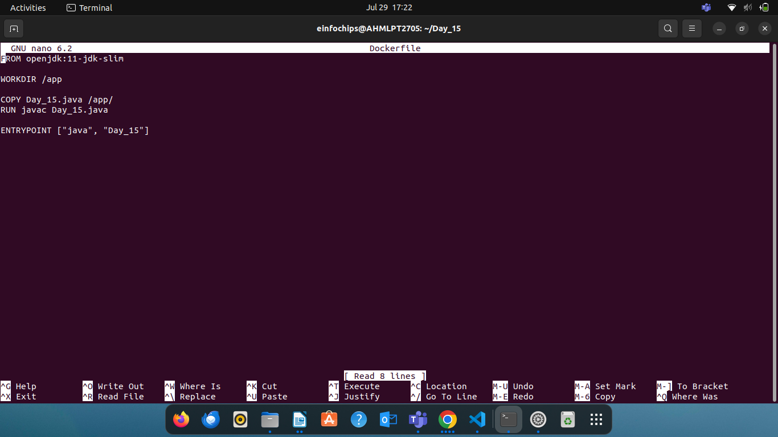

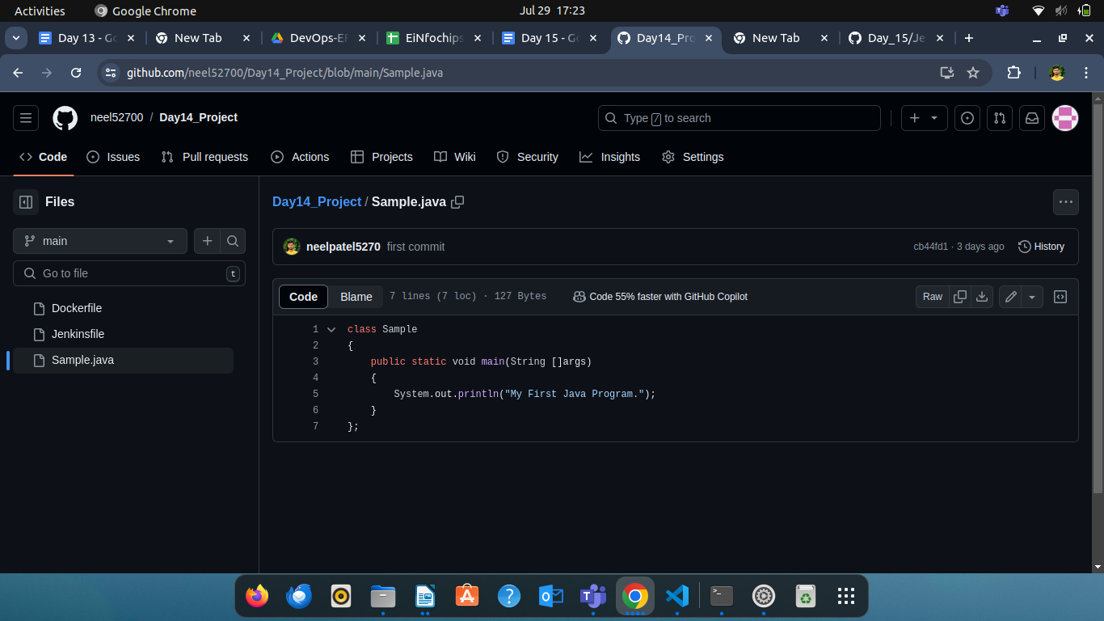

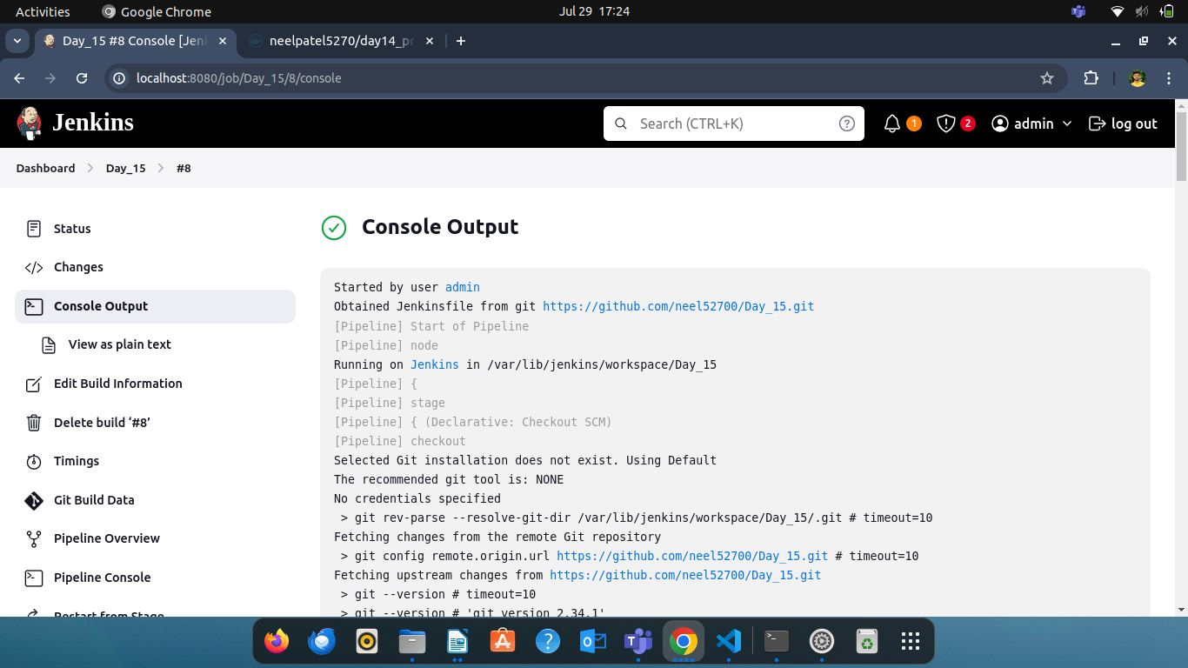

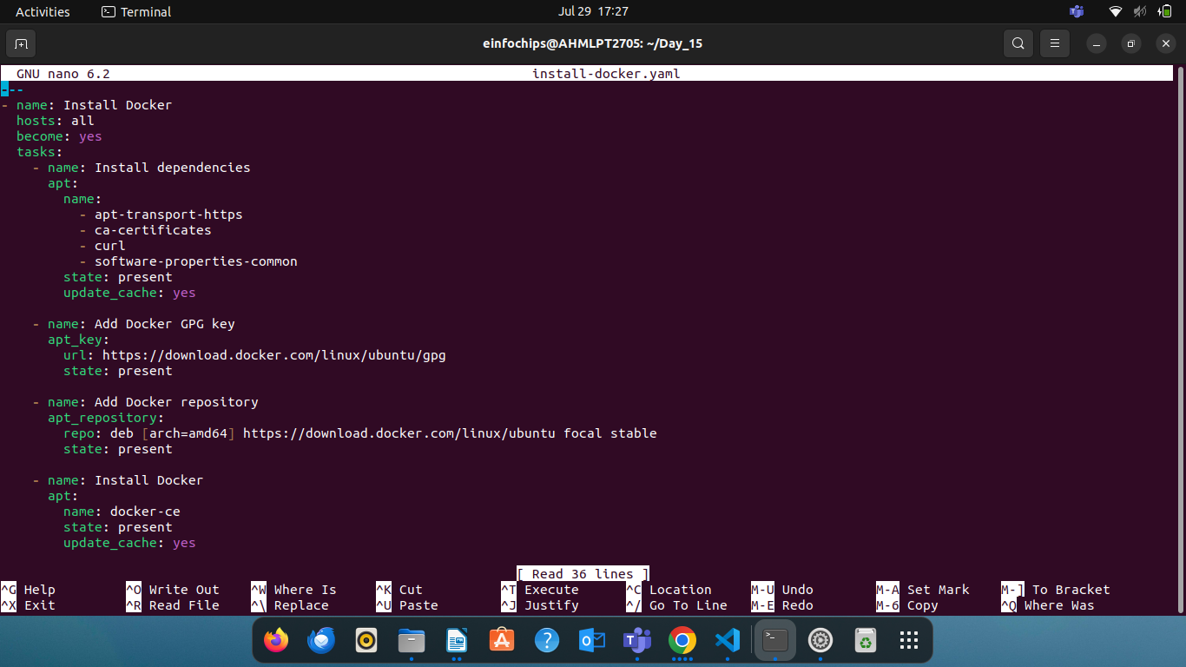
install-docker.yaml

Create Pull File

